

MS809 Enterprise Systems
Final Assessment


In submitting this work I confirm that it is entirely my own. I acknowledge that I may be invited to undertake an online interview if there is any concern in relation to the integrity of my submission.
SUBmitted by
amit kumar
24236930

Table of Contents
Question 1 2
1. Diversification 2
2. Coordination 2
3. Replication 3
4. Unification 3
Summary of Operating Models 4
How These Models Affect Growth and Innovation 4
Using More Than One Model 5
Impact on IT and Business Processes 5
Conclusion 6
Question 3 7
1. How CRM Supports Customer-Facing Functions 7
How It Differs from ERP 7
2. The Three Types of CRM Processes 7
Delivery Processes 8
Support Processes 8
Analytical Processes 8
Overview of the Three Types of CRM Processes 9
Benefits Of Implementing CRM 10
3. Common Challenges Companies Face with CRM Implementation 10
4. Ethical Concerns Related to CRM 11
Conclusion 12
References 13

Question 1
Operating models are basically the way big companies organise their internal systems and processes to work better across different parts of the business. Especially for global companies, it’s important to have a clear operating model so they can manage efficiency, control, and also stay flexible enough to deal with different markets. There are four types of operating models: diversification, coordination, replication, and unification ^{[1]}.
The operating model is considered the first step in building what’s called a foundation for execution. This includes all the digital systems and infrastructure that support how a business runs every day ^{[2]}.

1. Diversification
This model is all about independence. In diversification, each business unit runs on its own, they have their own processes, systems, and customers. There’s very little sharing or coordination. This works well for companies that are involved in completely different industries ^{[1]}.
For example: Tata Group is a good example. Tata Motors and Tata Consultancy Services are both part of the group but operate very differently and independently. This allows them to be flexible and responsive in their own markets, but they don’t benefit from sharing resources or systems, leading to extra costs and duplication.
Also, because each unit uses its own IT systems, it’s harder to implement common strategies or changes. This lack of standardisation creates silos and can slow down the innovation ^{[2]}.

2. Coordination
In the coordination model, business units still have their own processes, but they share data and information. There’s high integration, meaning that even though operations are different, the units work together more strategically ^{[3]}.
For example: Imagine a cosmetic brand, they can share customer data across different product lines. For example, if one team learns something about skin care, that knowledge might help improve another product like shampoo.
This kind of shared learning helps improve the company overall, but it does require strong IT systems to manage all the shared information, can be tricky to coordinate between units. This model works best when you need to share insights, but don’t need the exact same processes ^{[2]}.

3. Replication
Replication is about repeating what works. Business units use the same systems and processes, but they don’t interact much. It’s like copying a successful business model and applying it in other markets ^{[1]}.
For example: McDonald’s is a classic replication example. No matter where you go in the world, McDonald's restaurants look and feel the same, from the menu to the layout to the ordering system.
This model allows companies to grow fast and keep things consistent, but it doesn’t give much room for local changes ^{[2]}.

4. Unification
This is the most centralised model. Everything is standardised and integrated. All business units follow the same processes and systems. It’s a one-size-fits-all approach ^{[1]}.
For example: Apple is a great example here. From designing products to delivering them to customers, everything is controlled centrally. This helps Apple maintain high quality and brand consistency everywhere in the world.
Unification is powerful because it gives the company control and efficiency, but it can also make the organisation less flexible ^{[2]}.

Summary of Operating Models

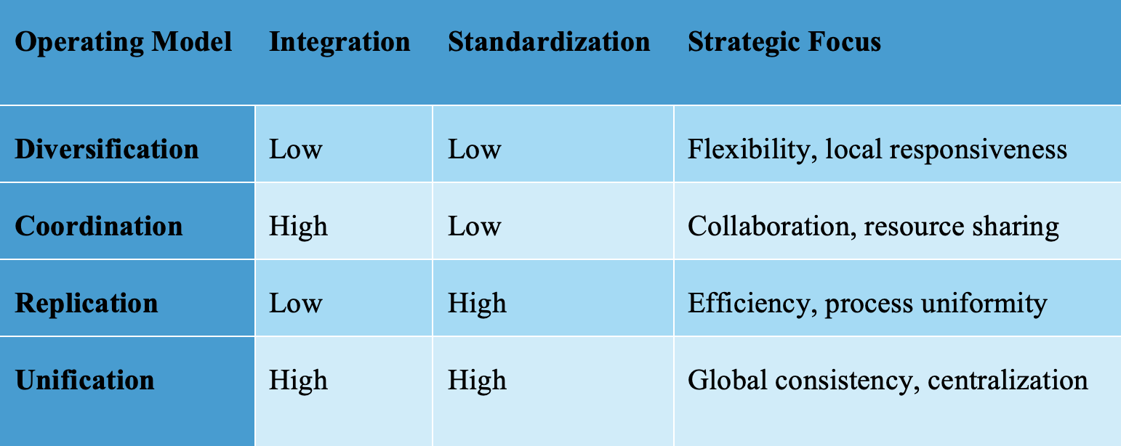
Table 1 - Operating Models Comparison
Comparing the four operating models Diversification, Coordination, Replication, and Unification based on their levels of integration and standardization, along with their primary strategic focus.

How These Models Affect Growth and Innovation
Each operating model influences how a company grows and adapts to change.
- Diversification encourages innovation within individual business units because teams have the freedom to make quick decisions based on local needs. However, this leads to siloed innovation, and successful practices might not be shared across the company ^{[2]}.
- Coordination allows units to share insights, making it easier to innovate collaboratively, but it can slow down the decision-making process due to the need for cross-unit alignment ^{[3]}.
- Replication drives growth by allowing companies to duplicate successful models in new regions quickly. It ensures consistency but limits creativity and local responsiveness ^{[2]}.
- Unification ensures consistent, high-quality outputs across all units. It can support global innovation when change is driven centrally, but it also risks being too rigid ^{[4]}.

Using More Than One Model
Many large firms operate in diverse markets and thus use multiple operating models at once. This hybrid approach lets them tailor strategies to different business units. For example, Nestle uses a diversification model for regional food brands like Maggi in India, giving local managers control over marketing and ingredients. At the same time, it uses unification for premium global brands like Nespresso to maintain brand consistency worldwide ^{[5]}.
While this strategy provides flexibility and efficiency, it’s not easy to manage. It requires a strong governance structure and enterprise architecture to avoid confusion and inefficiencies ^{[4]}. Also, IT systems must support multiple levels of integration and standardisation, which can be expensive and hard to coordinate.
To succeed with this approach, companies need a clear understanding of their strategic goals for each unit and must match their operating model accordingly. The goal is to balance agility and control while avoiding complexity that leads to inefficiency.

Impact on IT and Business Processes
Each model calls for a different IT setup.
- Diversification involves independent systems, increasing flexibility but limiting efficiency.
- Coordination uses shared platforms that allow collaboration without full standardisation ^{[3]}.
- Replication needs consistent, repeatable systems often cloud-based tools for reliable performance.
- Unification relies on centralised enterprise systems like global ERPs to manage operations uniformly ^{[2]}.
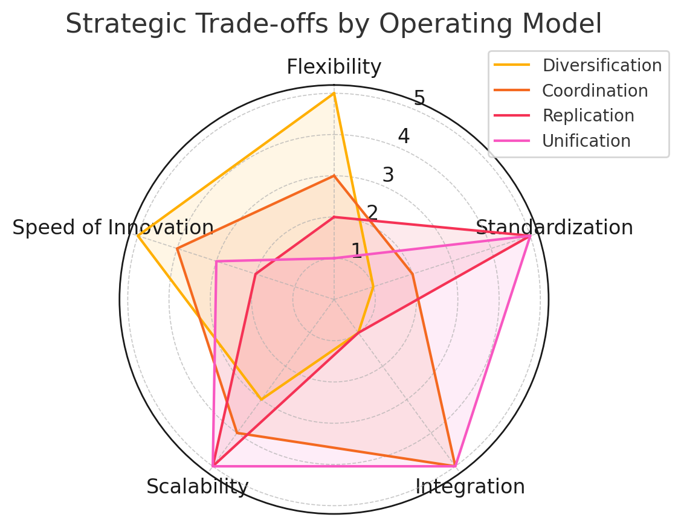
Figure 1 - Strategic Trade-offs by Operating Model
The shows that no model excels in all areas, each has its own advantages and compromises. For example, Diversification maximizes flexibility and innovation, while Unification prioritizes control and scalability.
The success of any model depends on aligning IT infrastructure with business needs. A mismatch can cause delays, duplication, and increased risk. When done right, IT becomes a powerful enabler of growth, agility, and innovation ^{[1]}.

Conclusion
To sum up, operating models help companies manage how they work across different business units. Each model has its pros and cons, and companies should choose the one that fits their goals. Some might even use more than one. What matters is having the right IT systems and clear strategy to make it all work smoothly.

Question 3
Customer Relationship Management (CRM) has come a long way from just being a digital contact book. Today, it plays a huge role in helping businesses connect with customers in meaningful ways by combining people, technology, and processes. In today’s competitive market, building long-term customer relationships is key to success. CRM systems give businesses the tools they need to better understand their customers, improve service, and make smarter decisions ^{[8]}.

1. How CRM Supports Customer-Facing Functions
CRM is all about supporting the parts of a business that interact directly with customers like sales, marketing, and customer service. These systems collect and organise customer data so businesses can personalise experiences, track communication, and build strong relationships. For example, sales teams can see what products a customer has bought before, marketing teams can send targeted offers, and customer service reps can resolve issues faster because they have access to a customer’s full history ^{[8]}.

How It Differs from ERP

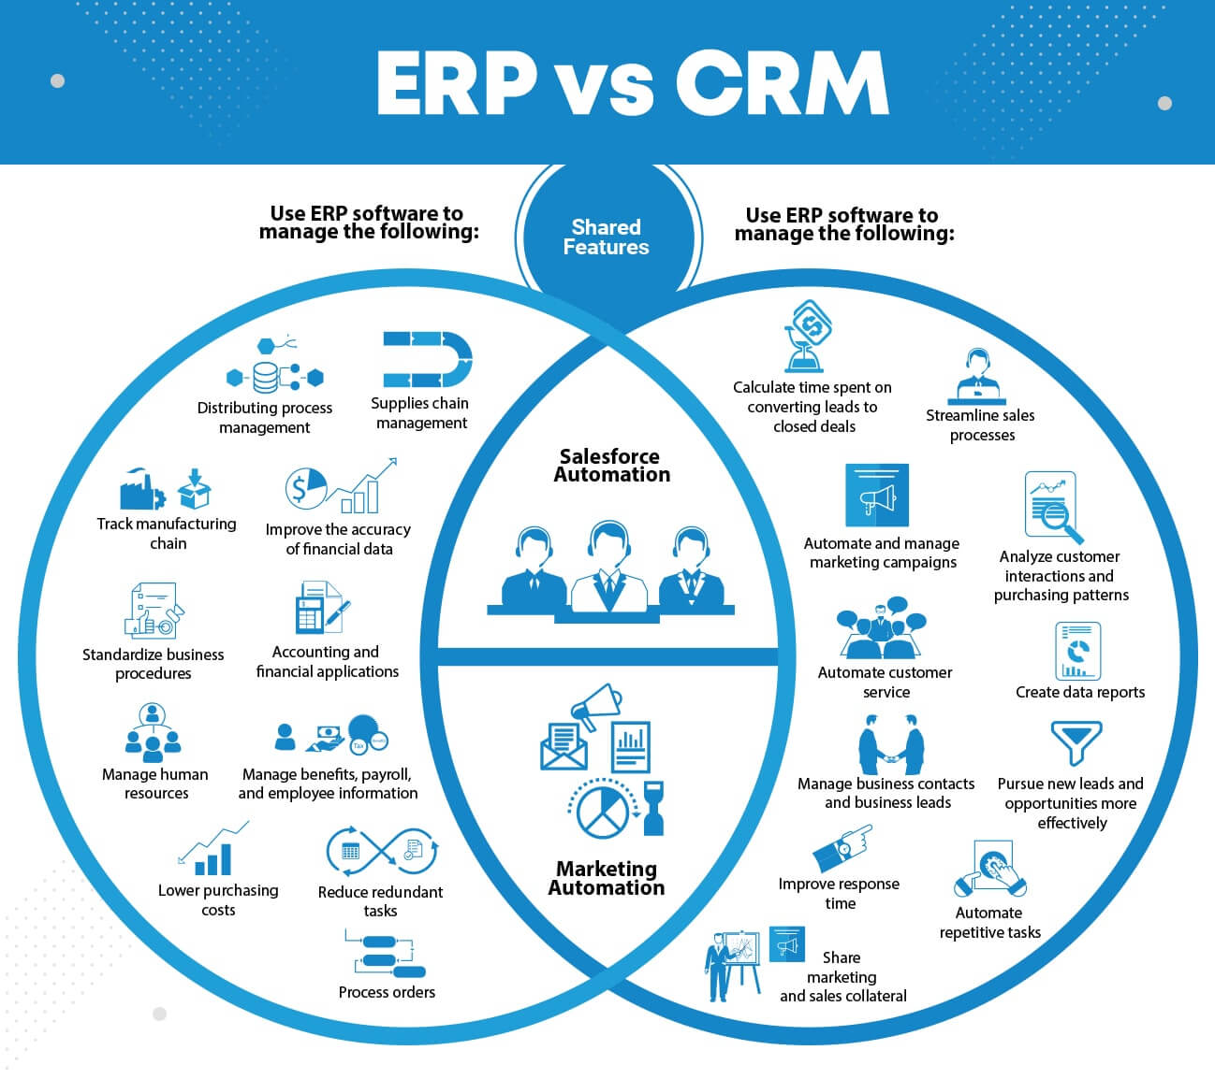
Figure 2 - ERP VS CRM ^{[14]}
CRM is different from ERP systems, which are more focused on backend processes like inventory, payroll, and finance. While ERP helps keep the business running efficiently behind the scenes, CRM is focused on the frontend making sure customers are happy and feel valued. Both systems are important, but they serve different purposes. A company that uses both CRM and ERP can manage its operations more holistically, ERP keeps things efficient internally, while CRM strengthens external relationships ^{[8]}.

2. The Three Types of CRM Processes
CRM processes fall into three main categories: delivery, support, and analytical processes. These all work together to improve the customer experience.

Delivery Processes
Delivery processes involve direct interactions between the business and its customers. These include managing communication channels like email, SMS and social media, automating marketing campaigns, handling customer inquiries, processing orders, and managing sales pipelines. This is where the customer feels the CRM system. This is the face of the business ^{[2]}.
For example: Imagine a small fashion brand called "Galway Fashion" that has a growing online presence but struggles to keep customers coming back. By using a CRM system, Galway Fashion could send personalized emails to customers based on their previous purchases, reminding them of similar new arrivals or offering discounts. This would likely increase return visits and loyalty over time.

Support Processes
Support processes work behind the scenes to enable employees to serve customers better. These include setting up internal systems, tools, and policies that empower teams with the information and resources they need.
Even the best customer service reps can't deliver quality service without access to accurate information and proper training. Support processes create consistency, reduce resolution time, and increase employee confidence ^{[2]}.
For example: Zappos is widely known for its exceptional service. They focus heavily on support processes by training employees extensively and giving them access to all customer information needed to solve problems fast. Their CRM systems are configured to support flexible yet accurate responses, which has helped build a loyal customer base ^{[9]}.

Analytical Processes
Analytical processes focus on turning customer data into actionable insights. These processes allow businesses to identify trends, segment customers, forecast demand, and personalize experiences based on data.
Raw data is useless without analysis. Analytical CRM helps businesses understand their customers deeply, make informed decisions, and stay competitive ^{[2]}.
For example: Netflix uses analytical CRM to track what users watch, when they watch, and what they skip. This data is then used to recommend content, send reminders, and even inform what kind of original shows they produce. This not only improves user experience but also guides high-stakes business decisions ^{[11]}.

Overview of the Three Types of CRM Processes

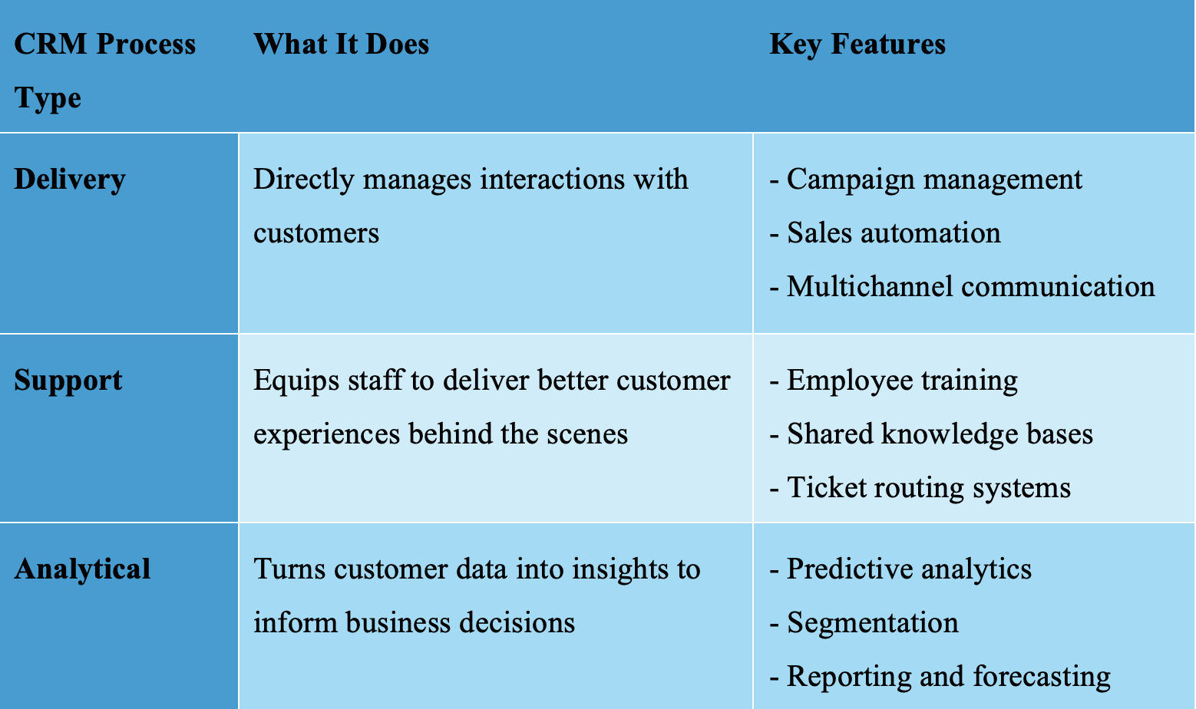
Table 2 - A comparison of three CRM processes highlighting their specific functions and key features.

Benefits Of Implementing CRM
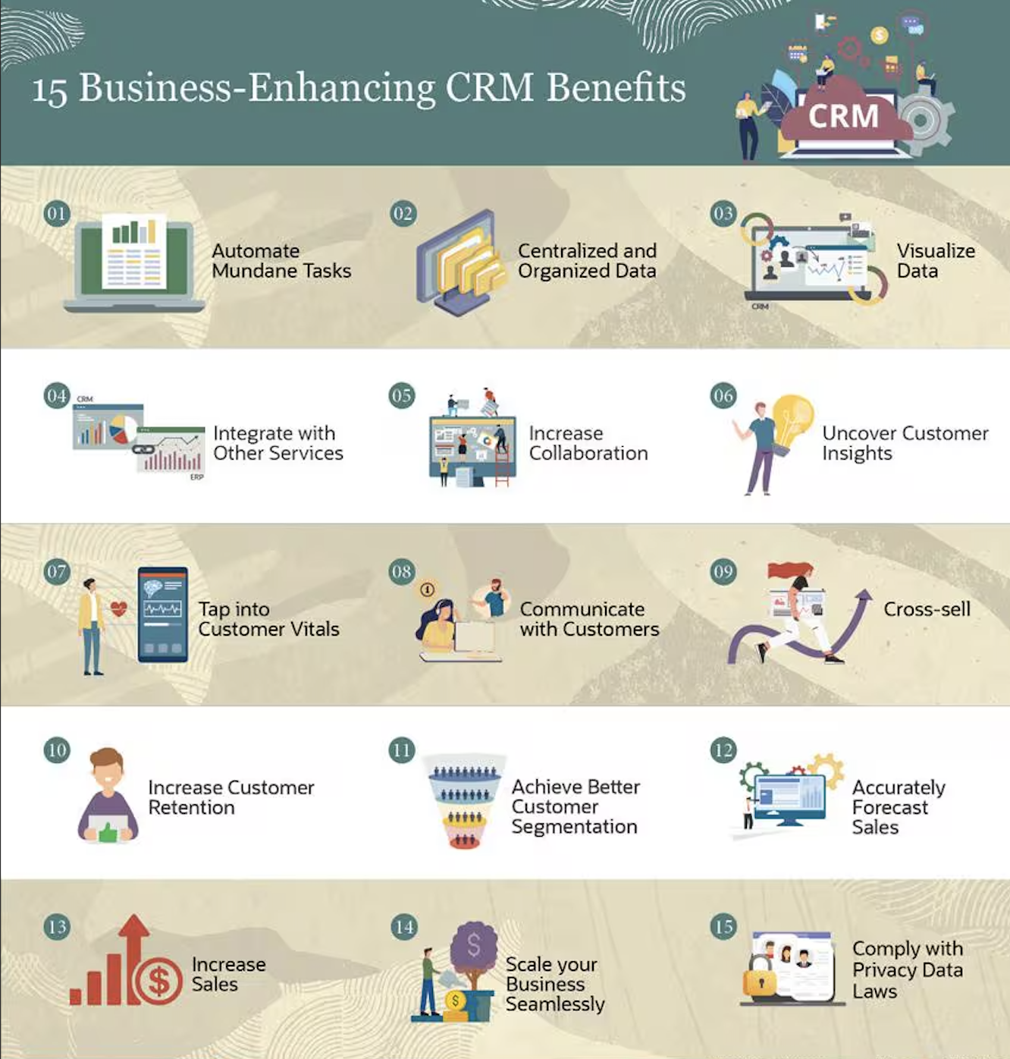
Figure 3 - Benefits of CRM implementation. ^{[9]}

3. Common Challenges Companies Face with CRM Implementation
Even though CRM offers lots of benefits, many companies run into problems when trying to implement it:
- Choosing the Right System: To ensure that the solution fits your business model, or if it doesn’t, can be modified to ^{[10]}.
- Integration issues: It’s not always easy to get CRM systems to work smoothly with older tools like ERP systems. This can cause delays and confusion ^{[10]}.
- Resistance to change: Employees might be hesitant to use new systems, especially if they’re used to doing things a certain way. Without proper training and support, CRM adoption can fail ^{[10]}.
- Data quality: CRM relies on good data. If the data is outdated, incomplete, or inconsistent, it can affect everything from marketing campaigns to customer service ^{[12]}.
- Costs and delays: CRM projects can become expensive, and without proper planning, they often go over budget or take longer than expected ^{[10]}.
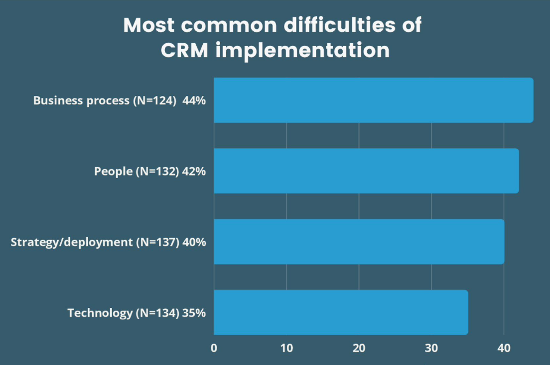
Figure 4 - Common Difficulties of CRM implementation by percentage. ^{[10]}
For example: Nike ran into trouble when trying to integrate CRM with its existing systems. They underestimated the complexity of merging data from different sources, which led to delays and increased costs. Eventually, with better planning and focus, they got the system running smoothly and saw improvements in customer engagement and targeted marketing ^{[13]}.

4. Ethical Concerns Related to CRM
CRM systems collect and store a lot of customer data, which raises important ethical questions.
- Privacy concerns: Customers expect their data to be safe. If companies don’t handle data responsibly, it can lead to serious privacy issues.
- Lack of transparency: Some businesses don’t clearly tell customers what data they’re collecting and why. This can lead to mistrust.
- Data misuse: Selling or sharing data without consent can damage a company’s reputation and lose customers’ trust ^{[6]}.
In my opinion, companies must take responsibility for handling customer data carefully and respectfully. If customers don’t trust how their data is used, they’re less likely to engage with the brand or share important information.
Some ways to address these concerns include:
- Making privacy policies simple and clear
- Letting customers opt out of data tracking
- Regularly auditing systems to check for misuse
- Following data protection laws like GDPR

Conclusion
CRM has become an essential part of how businesses build strong customer relationships. It supports key functions like marketing and service, provides data for better decision-making, and helps companies stand out in crowded markets. But to be successful, businesses need to plan their CRM implementations carefully, train their staff properly, and ensure their data is accurate and secure. Most importantly, they need to be ethical and transparent about how customer information is used. When done right, CRM can create long-term value for both the company and its customers.

References

- Ross, J.W., Weill, P. and Robertson, D. (2006). Enterprise architecture as strategy : creating a foundation for business execution. Boston, Mass.: Harvard Business School Press.
- Isazad Mashinchi, M. (2025). MS809 – Enterprise Systems, Week 9 Lecture Slides: Operating Model. University of Galway.
- Weill, P. and Ross, J.W. (2010). IT savvy : what top executives must know to go from pain to gain. Boston, Mass.: Harvard Business Press.
- Weill, P., & Woerner, S.L. (2018). What's Your Digital Business Model? Six Questions to Help You Build the Next-Generation Enterprise. Harvard Business Review Press.
- Smith, H., & Fingar, P. (2011). Business Process Management: The Third Wave. Meghan-Kiffer Press.
- Wani, S. (2023). Ethical Considerations in CRM: Protecting Customer Data and Privacy. [online] Medium. Available at: https://medium.com/@shreesagarwani/ethical-considerations-in-crm-protecting-customer-data-and-privacy-16c2998013a4.
- Inc, G. (n.d.). CRM Customer Engagement Center (CEC) Reviews 2023 | Gartner Peer Insights. [online] Gartner. Available at: https://www.gartner.com/reviews/market/crm-customer-engagement-center.
- Motiwalla, L., & Thompson, J. (2012). Enterprise Systems for Management. Pearson Education.
- NetSuite.com (2022). 15 Key CRM Benefits for Businesses. [online] Oracle NetSuite. Available at: https://www.netsuite.com/portal/resource/articles/crm/crm-benefits.shtml.
- Sciandra, P. (2022). Top Challenges of CRM Implementation. [online] OMI. Available at: https://www.omi.co/crm-configuration/top-challenges-of-crm-implementation/.
- Perez-Vega, R., Hopkinson, P., Singhal, A. and Mariani, M.M. (2022). From CRM to social CRM: A bibliometric review and research agenda for consumer research. Journal of Business Research, [online] 151, pp.1–16. Available at: https://www.sciencedirect.com/science/article/pii/S0148296322005665.
- Sage Software. (n.d.). Top Challenges in CRM Implementation. [online] Available at: https://www.sagesoftware.co.in/blogs/top-challenges-in-crm-implementation/.
- Vyas, P. (2021). 6 Benefits of a Cloud-Based CRM. [online] Synoptek. Available at: Click or tap here to enter text.https://synoptek.com/insights/it-blogs/benefits-of-cloud-based-crm/.
- Deskera Blog. (2021). CRM vs ERP | A Complete Comparison. [online] Available at: https://www.deskera.com/blog/crm-vs-erp/.

